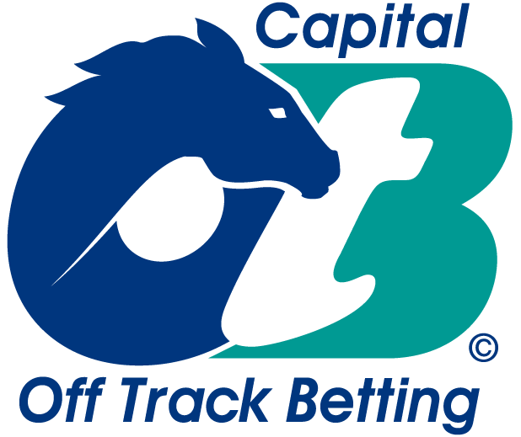

“WIN A BET” ($100)
Saturday, December 14th, 2019 – Online

Rules on the back

Race Selections Price
(Please place number selection here) (For OTB Marketing Staff use only)

Aqueduct races 4-6

Race 4: Win______ __________ (x 4)

Race 5: Win______ __________ (x 5)

Race 6: Win______ __________ (x 6)

Gulfstream Park races 7-9

Race 7: Win______ __________ (x 7)

Race 8: Win______ __________ (x 8)

Race 9: Win______ __________ (x 9)

Winner- $75 deposit and runner-up - $25 deposit.

Total: ________________

**Online

Patron’s Name: __________________________________________

Capital OTB’s “Win A Bet”

Rules:

1. One entry per person. Contestants submitting multiple entries will be disqualified. Contestants must be present to be eligible for prizes. All entries must be submitted prior to the 4th race at Aqueduct.

2. The contest will involve races 4-9 @ AQ/GP. Capital OTB reserves the right to change the contest track in advance due to extreme weather conditions, cancellation of the racing card, or other factors at the discretion of Capital OTB marketing staff.

3. Each contestant must select the horse or entry, which they feel, will finish in 1st in contest races. If your selection is scratched before the race, you will automatically inherit the post time favorite. Contestants will automatically be disqualified for failure to select a runner or entry in each race.

4. If your 1st place selection finishes in 1st place, you will receive the win price times the number race. Ex: race 6 is price times 6, race 7 is price times 7…etc. Win prices are capped at 20-1 ($42). Highest cumulative scores are the winner and runner-up.

5. Tiebreakers – If there is a tie, winner will be decided by most wins. If a tie still exists, one entry, from the tied entries, will be drawn at random by OTB Marketing staff and declared the winner.

6. Any patron participating in the contest cannot transfer their prize winnings to another patron. All prizes are non-transferrable. Employees of Capital OTB, and its contractors and vendors are ineligible to participate.

7. Winner of the contest receives a $75 deposit and runner-up a $25 deposit.

- All decisions by Capital OTB management are final.
- Winners must be willing to sign a W-9 form.

